**Computational evaluation of biological activities of the selected bioactive compound library on human beta1 adrenergic receptor**

**Abstract**:   
  
ADRB1, or the beta-1 adrenergic receptor, belongs to the G-protein coupled receptor family, representing a key class of transmembrane proteins. Beta-1 adrenoceptors are predominantly associated with cardiovascular functions and thus serve as critical targets for therapeutic interventions. Advances in silico molecular docking techniques have enabled new opportunities to identify bioactive therapeutic leads for β1-AR. This study utilised a combination of computational bioinformatics tools and virtual screening methodology to identify effective bioactive compounds docked into β1-AR. Interaction studies revealed hydrogen bonding and hydrophobic interactions between candidate ligands and critical amino acids at key binding sites. Binding affinities were assessed using scoring functions, and top-ranked compounds underwent analysis for drug-likeness and ADMET properties. This research identified several promising β1-AR modulators with favourable pharmacokinetic profiles, paving the way for validation through in vitro and in vivo studies. The findings underscore the utility of molecular docking in the rational design of selective β1-AR therapeutics, accelerating drug discovery in cardiovascular medicine.

**Introduction:**Beta-1 receptors, along with beta-2, alpha-1, and alpha-2 receptors, are adrenergic receptors primarily responsible for signalling in the sympathetic nervous system. Beta-agonists bind to the beta receptors on various tissues throughout the body. Beta-1 receptors are predominantly found in three locations: the heart, the kidney, and the fat cells. The beta-1 adrenergic receptor, a G-protein-coupled receptor, communicates through the Gs alpha subunit to initiate a cAMP-dependent pathway via adenylyl cyclase, enhancing receptor function. In the heart, activation of the beta-1 receptor increases sinoatrial and atrioventricular nodal activity, ventricular contraction, heart rate, and contractility, thereby raising stroke volume and cardiac output. This boosts tissue perfusion throughout the body. In the kidney, beta-1 activation promotes renin release from juxtaglomerular cells, leading to increased blood volume via angiotensin II and aldosterone. In adipocytes, it stimulates lipolysis.

Hormones such as epinephrine, dopamine, and isoproterenol target beta-1 and beta-2 receptors equally, while norepinephrine and dobutamine have greater specificity for beta-1 receptors. These pathways can be pharmacologically modulated to activate or block beta-1 receptors, offering therapeutic potential for various conditions.  
  
Pathogenesis involving β1-AR often occurs in conditions of chronic stress, hypertension, or heart failure, where prolonged stimulation leads to receptor desensitisation, downregulation, and maladaptive signalling. Overactivation of β1-AR can increase cardiac workload, contribute to left ventricular hypertrophy, and promote arrhythmias by enhancing calcium overload in cardiac myocytes. Moreover, β1-AR autoantibodies, commonly seen in autoimmune diseases and dilated cardiomyopathy, can mimic catecholamines, causing sustained stimulation and myocardial damage. These pathophysiological processes contribute to heart failure progression, cardiac remodelling, and other cardiovascular diseases.  
  
Molecular docking is a procedure to find the best possible drug candidate that binds to the protein target. The criterion for finding the best candidate is the lowest free energy, as a lower G value indicates more stable binding. It is a computational process that helps understand the interactions between a small molecule (ligand) and a protein target at the molecular level. Molecular docking predicts the preferred orientation of the ligand within the binding site of the protein, enabling researchers to assess the strength and specificity of the interaction. This process often involves the use of scoring functions to evaluate binding affinities based on intermolecular forces such as hydrogen bonding, van der Waals forces, hydrophobic interactions, and electrostatic interactions. Docking studies are widely employed in drug discovery and development to screen large libraries of compounds, prioritise potential drug candidates, and optimise their binding efficiency before experimental validation. Additionally, molecular docking can provide insights into key binding residues, guiding rational drug design to improve selectivity and efficacy against the target protein.  
  
In this project, 10 drug candidates were chosen which were then docked onto the target site to determine the best binding drug molecule. The ADMET properties and other properties of the drug molecule were also described.

**Information about molecules:**Target molecule: **7BVQ - Structure of human beta1 adrenergic receptor bound to carazolol**  
  
Drug molecules:  
  
1. **Acadesine**: Acadesine (AICA-riboside) is an adenosine-regulating agent primarily investigated for its potential cardioprotective effects, particularly in ischemia-reperfusion injuries during heart surgery. It has also been studied for its role in activating AMP-activated protein kinase (AMPK), which may have implications in metabolic disorders and cancer therapy.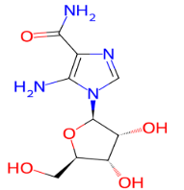

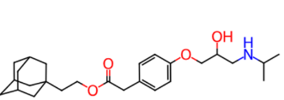

2. **Adaprolol**: Adaprolol is a non-selective beta-adrenergic antagonist primarily studied for its potential cardiovascular effects, such as reducing blood pressure and heart rate. It has also been investigated for its role in managing conditions like hypertension and arrhythmias by blocking beta-adrenergic receptors and decreasing sympathetic nervous system activity.

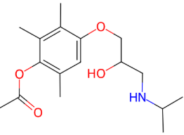

3. **Metipranolol**: Metipranolol is a non-selective beta-adrenergic antagonist primarily used in ophthalmology to lower intraocular pressure in patients with glaucoma or ocular hypertension. It works by reducing aqueous humor production, thereby helping to prevent optic nerve damage and vision loss.

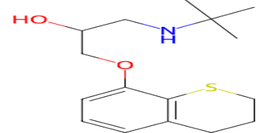

4. **Tertatolol**: Tertatolol is a non-selective beta-adrenergic antagonist with mild intrinsic sympathomimetic activity, primarily used in the treatment of hypertension and angina pectoris. By blocking beta receptors, it helps reduce heart rate and cardiac workload, contributing to better control of blood pressure and relief from chest pain.  
  
5. **Penbutolol**: Penbutolol is a non-selective beta-adrenergic antagonist with intrinsic sympathomimetic activity, used primarily for managing hypertension. Its partial agonist activity allows it to lower blood pressure while minimizing the risk of severe bradycardia or bronchoconstriction, making it a suitable option for certain patients.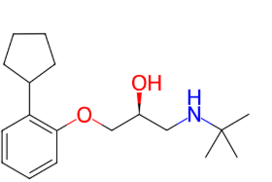

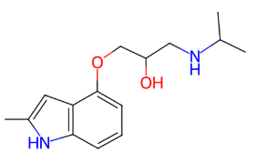

6. **Mepindolol**: Mepindolol is a non-selective beta-adrenergic antagonist with intrinsic sympathomimetic activity, primarily used in the treatment of hypertension and certain cardiovascular disorders. It helps reduce blood pressure by blocking beta-adrenergic receptors, while its partial agonist activity minimizes adverse effects like excessive bradycardia.

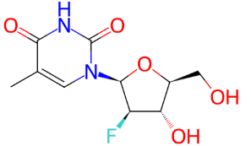

7. **Clevudine**: Clevudine is an antiviral nucleoside analog used for the treatment of chronic hepatitis B virus (HBV) infection. It works by inhibiting viral DNA polymerase, thereby preventing the replication of HBV and reducing viral load in infected individuals.

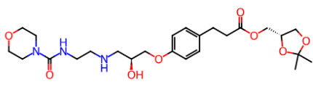

8. **Landiolol**: Landiolol is an ultra-short-acting, highly cardio selective beta-blocker primarily used for managing tachyarrhythmias and controlling heart rate in critically ill patients. It offers rapid onset and precise dose titration, making it ideal for acute cardiovascular interventions with minimal impact on blood pressure.

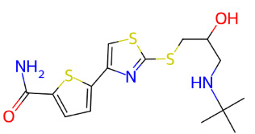

9. **Arotinolol**:

Arotinolol is a non-selective beta-adrenergic blocker with additional alpha-1 adrenergic blocking properties, used to manage hypertension and essential tremors. Its dual action helps lower blood pressure by reducing heart rate (beta-blockade) and relaxing vascular smooth muscles (alpha-blockade), offering a unique profile among adrenergic blockers.

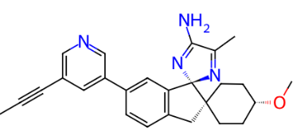

10. **Lanabecestat**: Lanabecestat is an experimental drug that acts as a beta-secretase (BACE1) inhibitor, developed for the treatment of Alzheimer’s disease. It aims to reduce amyloid-beta production, a key protein involved in the formation of amyloid plaques associated with the progression of Alzheimer’s, but clinical trials were discontinued due to a lack of efficacy.

**Materials and methods:**The name of the protein was first searched in Uniprot to find a Swiss-prot human version of the protein.   
  
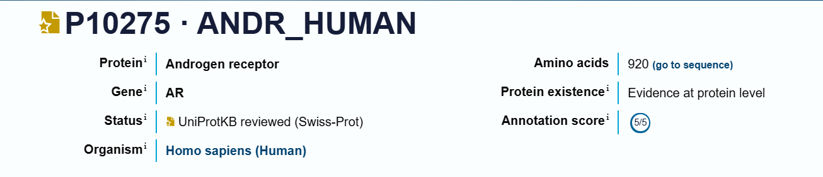

The PDB structure with accession 7BVQ was chosen from the structure list and downloaded as *7bvq.pdb*.  
  
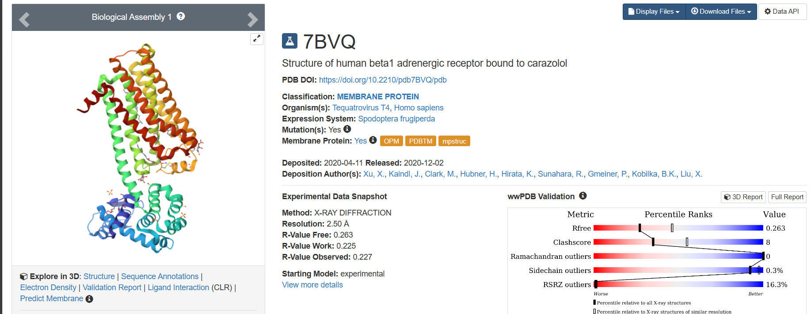  
  
The structure was loaded onto the discovery studio and ligands, water molecules, heteroatoms and other unwanted elements were removed to keep only the protein chains and the file was saved as *7bvq_cleaned.pdb*  
  
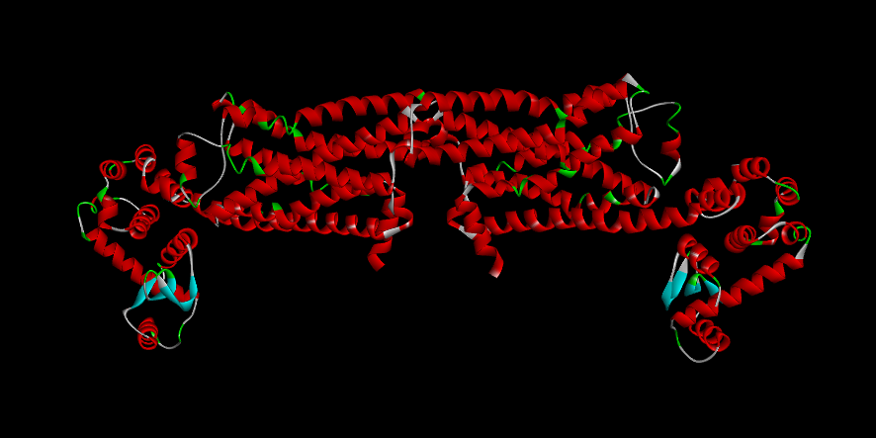  
 **Fig: *7bvq_cleaned.pdb***

The structure was further modified to add hydrogen atoms and further cleaned to remove more elements like chain B of the protein and other heteroatoms and structures that could not be removed using the discovery studio method. This was done by manually editing the PDB files in Notepad to yield the PDB file *7bvq_ready.pdb* which would be used for docking.

**Fig: *7bvq_ready.pdb***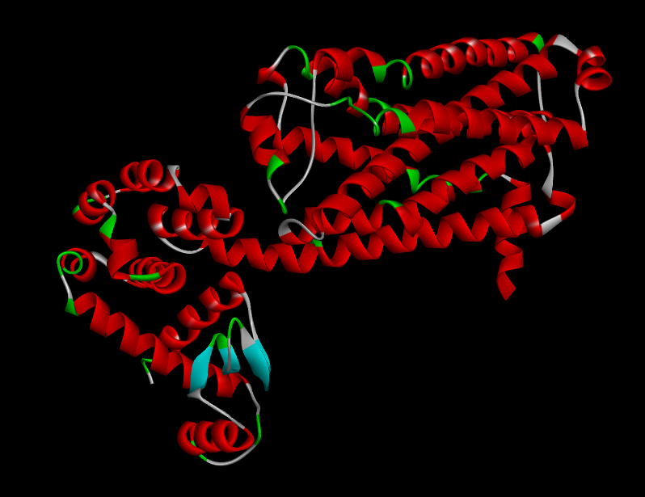

The structure was loaded onto PyRx and was made into a macromolecule.

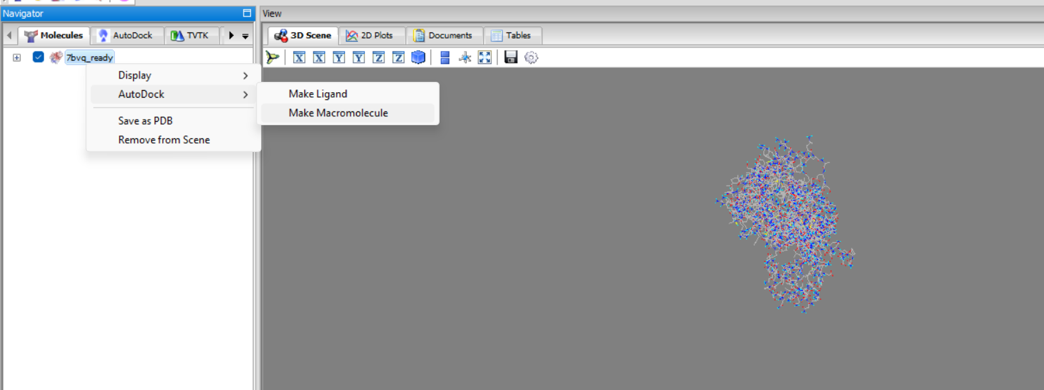  
  
  
The 3D structures of the 10 bioactive drug molecules were downloaded from PubChem in SDF format.   
  
  
The molecules were loaded onto the PyRx platform under the OpenBabel tab.

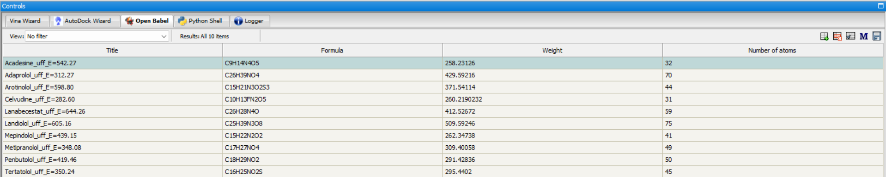The drug molecules were all minimised and converted to autodock ligands (pdbqt format) to prepare them for docking.   
 **Fig: Minimisation**

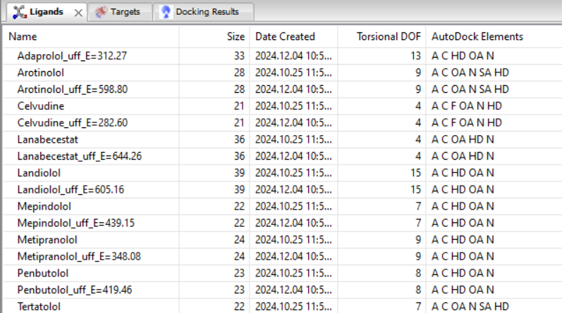

**Fig: Converted to auto dock ligand (pdbqt format)**

The start option in the AutoDock wizard was selected and all the ligands were selected as well in the ligand tab.  
  
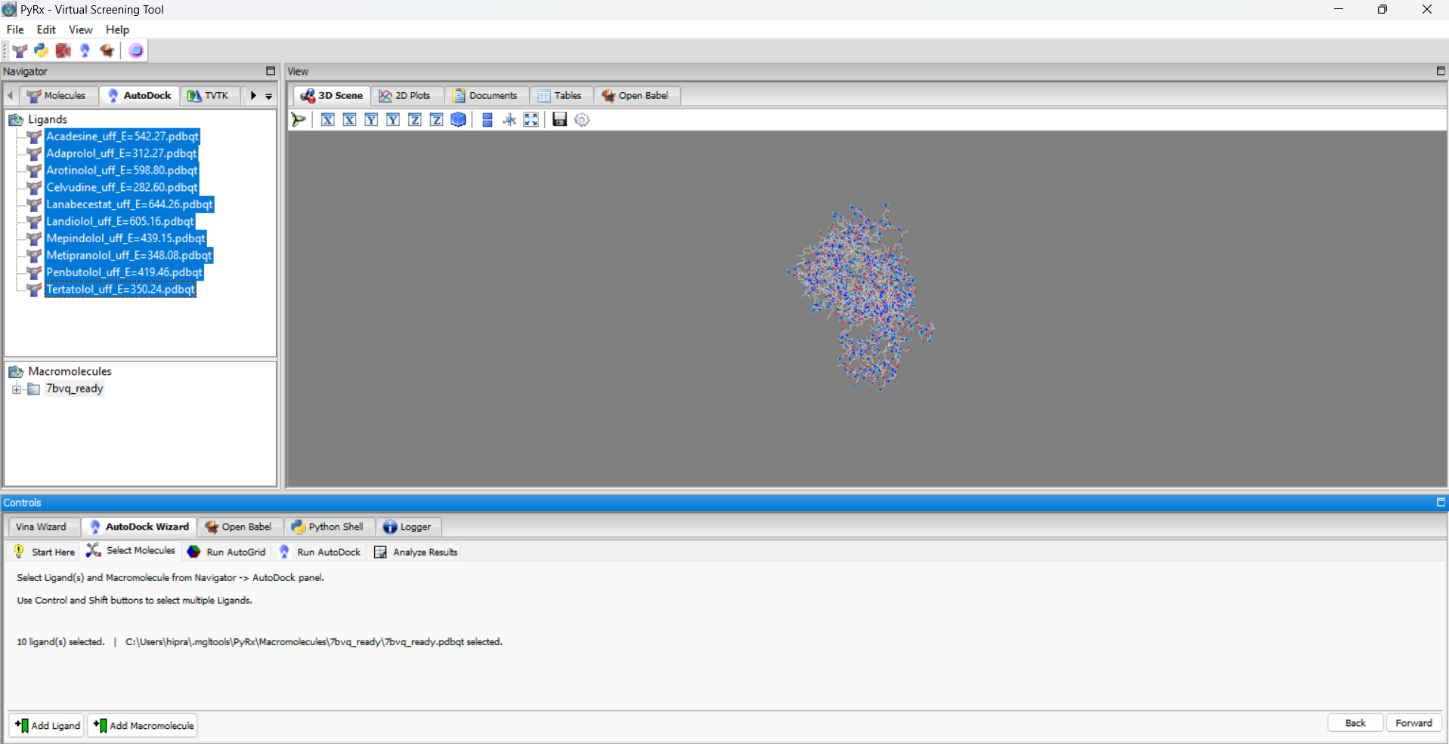

The forward button was clicked to fit a 3D box around the protein molecule to define the area where the docking needs to occur, the box dimensions were adjusted manually to make sure all the atoms were included.  
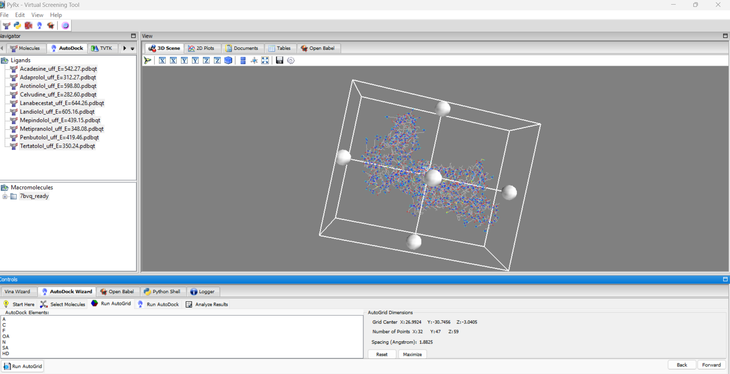

The forward option was selected to begin the docking process  
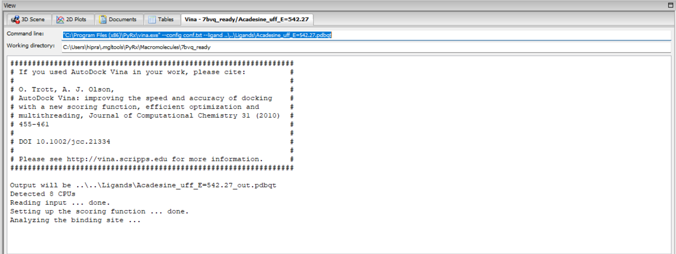

Once the completion of the process is done, the CSV file of the docking results are downloaded and the results are filtered to yield only those with an rmsd (upper and lower bound) = 0

Trial 1 results:  
  
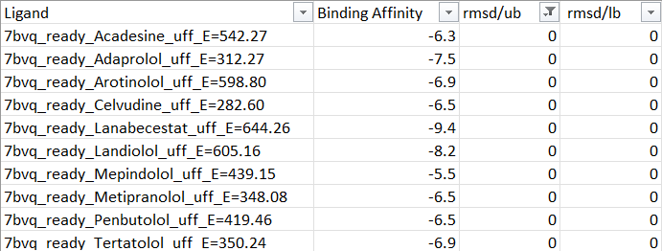

The molecule’s structure with the lowest binding affinity is downloaded after docking from PyRx and is saved as *docked1.pdb*The structures of *docked1.pdb* and *7bvq_ready.pdb* are loaded onto PyMol to visualise the drug-target binding.

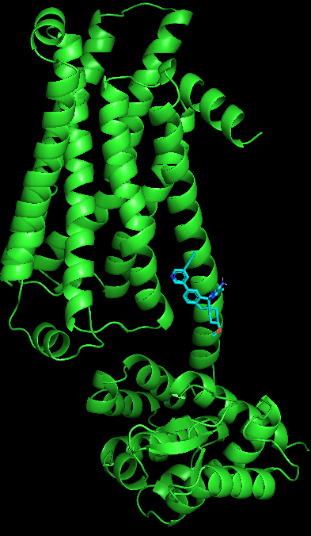

*ligand1.pdb*  
  
The *ligand1.pdb* file is loaded onto LigPlot+ to visualise the amino acids in the binding site. This can also be done using Discovery Studio.

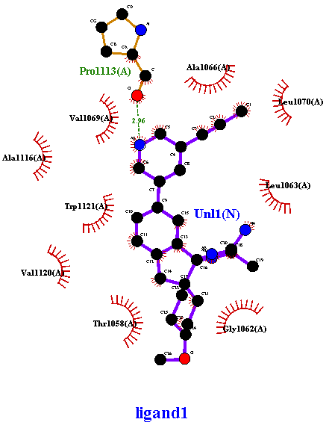

LigPlot+ results

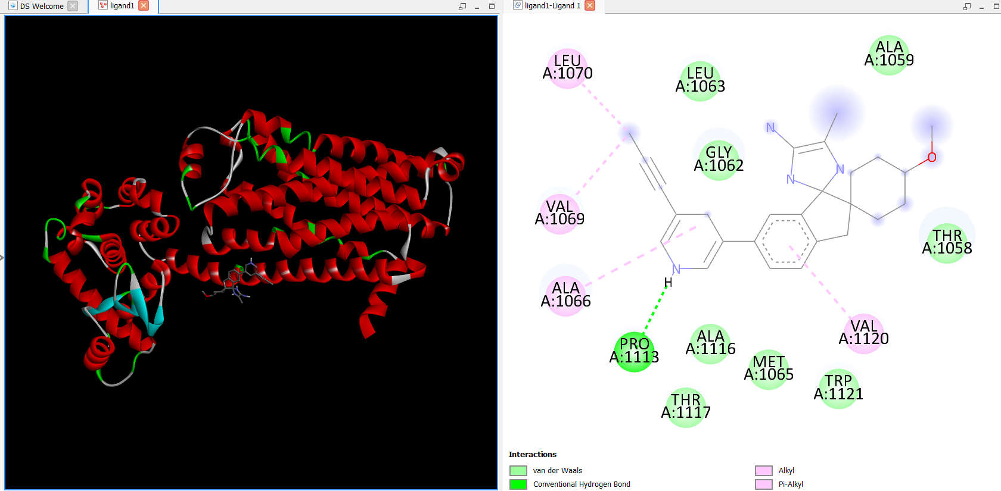  
  
 Discovery studio results  
  
  
Similarly, two more trials are done to better understand and confirm the actual results.

**Trial 2 results:**  
  
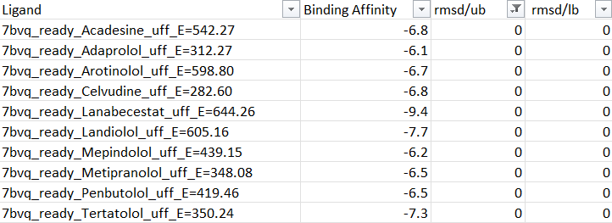

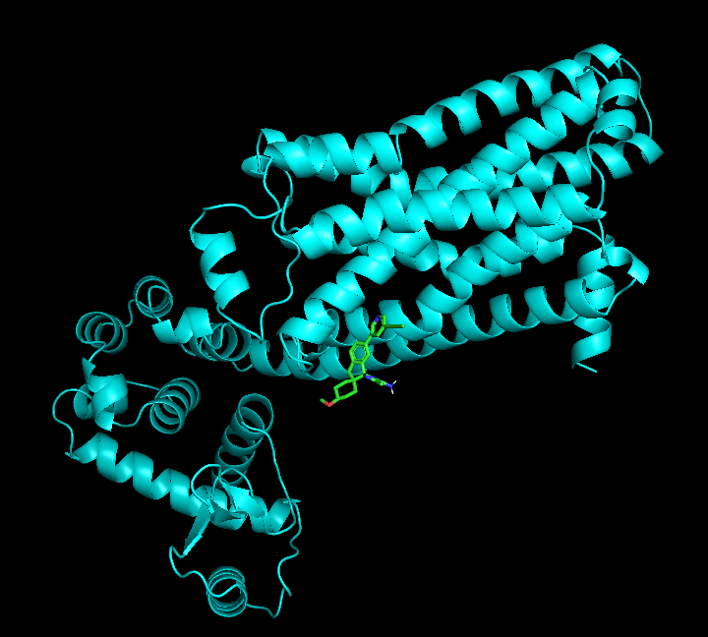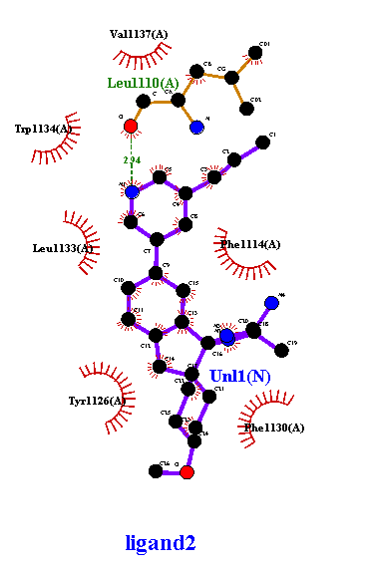

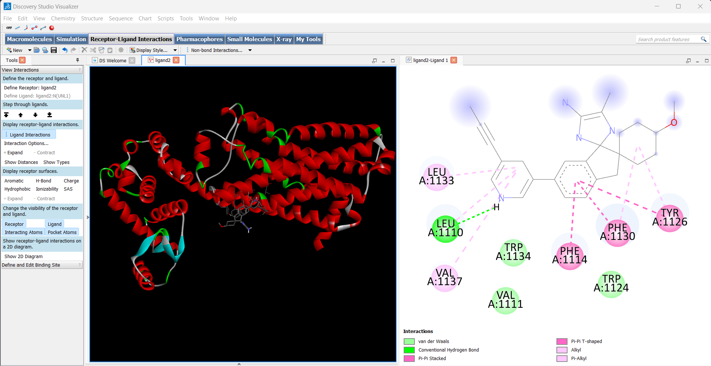

**Trail 3 results:**  
  
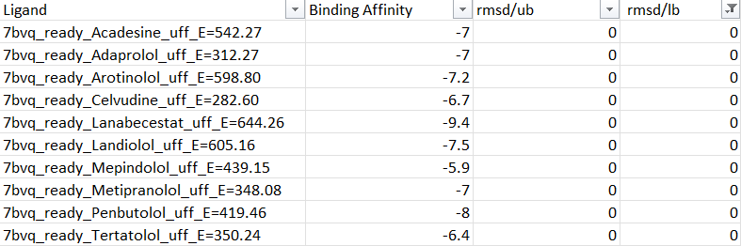

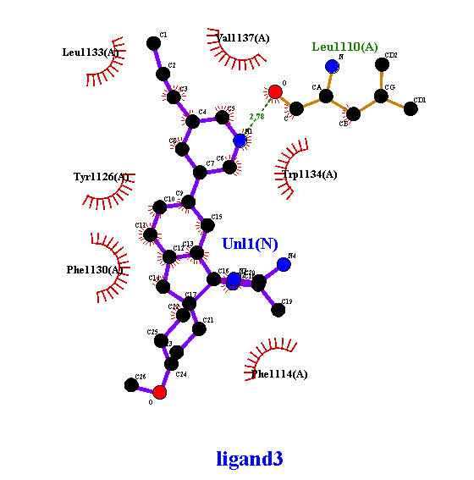

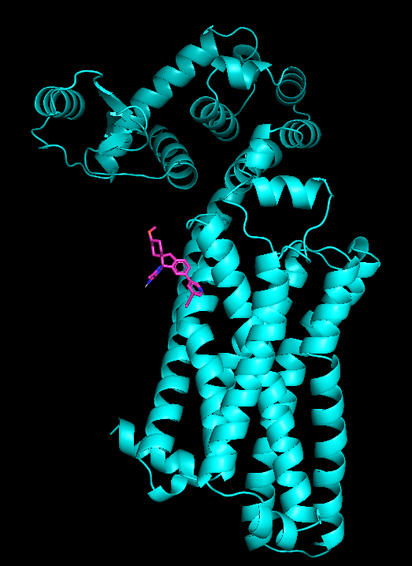

**Results:**

|  |  |  |  |
| --- | --- | --- | --- |
| Trail No. | 1 | 2 | 3 |
| The binding affinity of the drug | -9.4 | -9.4 | -9.4 |
| Name of drug | Lanabecestat | Lanabecestat | Lanabecestat |

The ADMET properties of Lanabecestat are found using the tool ADMETLab 3.0, which is a vast database consisting of data on many properties of various drug molecules.

**ADMET property:**  
  
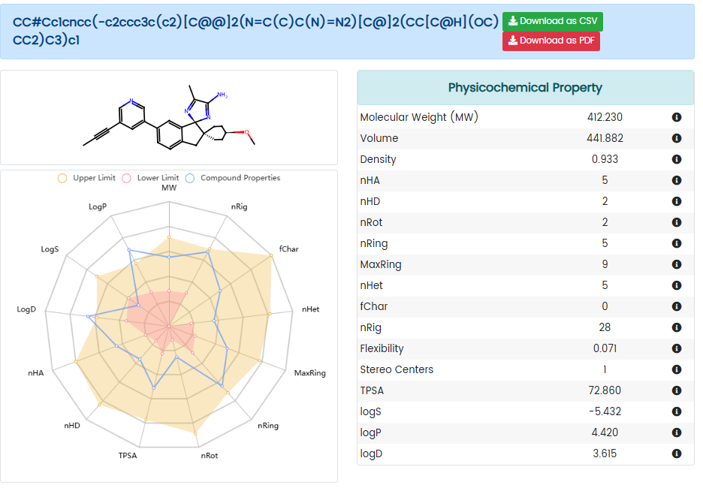  
  
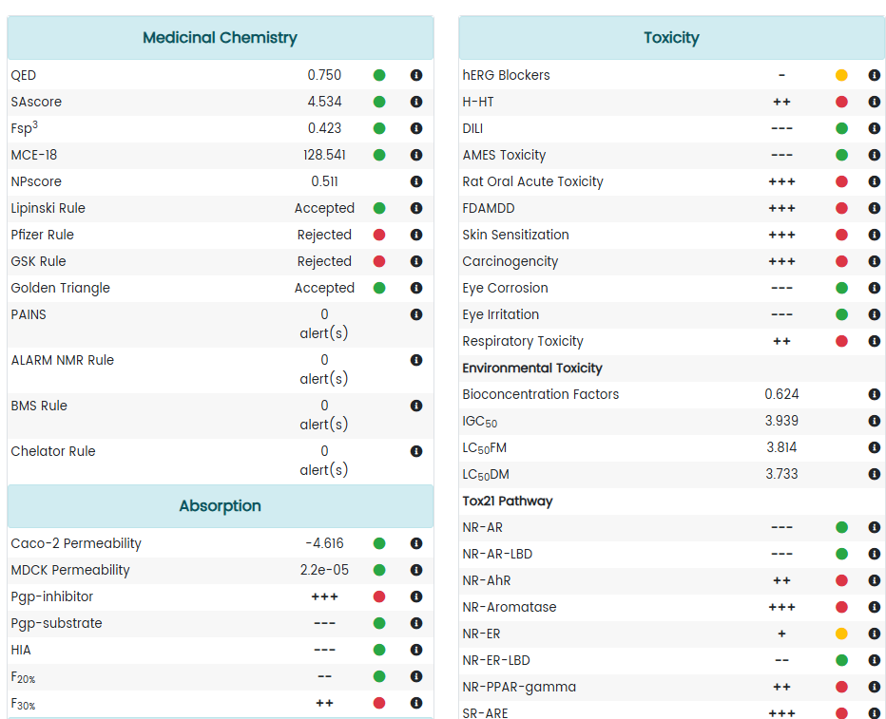

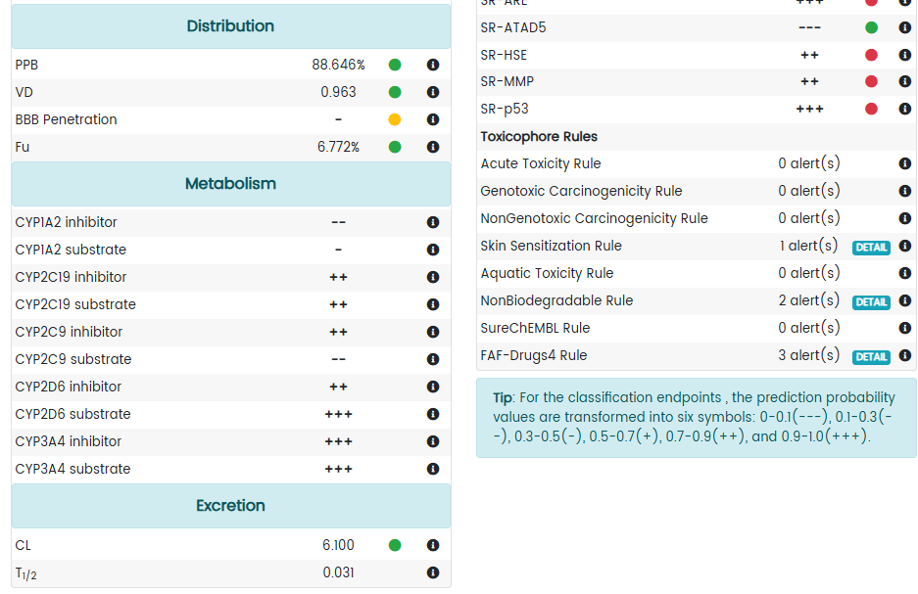

**References:**1. S. Alhayek and C. V. Preuss, “Beta 1 Receptors,” PubMed, 2020. <https://pubmed.ncbi.nlm.nih.gov/30422499/>

2. “Beta 1 Adrenergic Receptor - an overview | ScienceDirect Topics,” www.sciencedirect.com. <https://www.sciencedirect.com/topics/medicine-and-dentistry/beta-1-adrenergic-receptor>

3. S. F. Steinberg, “Beta 1 -Adrenergic Receptor Regulation Revisited,” Circulation Research, vol. 123, no. 11, pp. 1199–1201, Nov. 2018, doi: <https://doi.org/10.1161/circresaha.118.313884>.

4. “β1-adrenoceptor | Adrenoceptors | IUPHAR/BPS Guide to PHARMACOLOGY,” Guidetopharmacology.org, 2018. <https://www.guidetopharmacology.org/GRAC/ObjectDisplayForward?objectId=28>